PRESS RELEASE
Source: University of Electro-Communications, Tokyo,
For immediate release: 21 October 2015
University of Electro-Commuincations, Tokyo research: Nanoislands and skeletal skin boost fuel cell performance
(Tokyo, 21 October 2015) Selective electrodeposition of tin oxide on platinum alloy nanoparticles provides an effective and robust catalyst for polymer electrolyte fuel cells, report researchers in Japan.
Polymer electrolyte fuel cells (PEFC) could provide an alternative to traditional fossil fuel power, but higher performance and durability under harsh conditions are needed before PEFC vehicles can be considered commercially viable. Now researchers at the University of Electro-Communications, the University of Tokushima and Japan Synchrotron Radiation Research Institute in Japan have synthesised catalysts from platinum cobalt (PtCo₃) nanoparticles on carbon (C) with tin oxide (SnO₂) nanoislands and shown that they perform better than any previously reported.
Fuel cell research has focused on platinum alloys and transition metal oxides to improve on the durability and catalytic performance of platinum on carbon. Previous work with SnO₂ islands grown on platinum tin alloy with carbon had already shown some improvement in the oxygen reduction reactions that occur in fuel cells. However growing islands of only SnO₂ on other alloys posed a challenge.
Now Yasuhiro Iwasawa at the University of Electro-Communications and his colleagues have grown SnO₂ islands on Pt₃Co nanoparticles on carbon (Pt₃Co/C) by selective electrochemical deposition of tin metal, which is then oxidized. The addition of the SnO₂ nanoislands doubled the catalytic performance of the Pt₃Co/C catalysts. In addition they were undamaged after undergoing 5000 cycles of voltage changes to test their durability.
The structure the Pt₃Co nanoparticles form has a Pt₃Co core surrounded by a platinum skin that has a rough – “skeleton” – morphology. The researchers attribute the high catalytic performance in part to efficient electronic modification specifically at the platinum skin surface, and in particular to the unique property of the SnO₂ nanoislands at the compressive platinum skeleton-skin surface.
“In general, adhesion of transition metal oxides on carbon induces depression of the electrical conductivity of the carbon,” explain the researchers in their report. “Hence, the selective nano-SnO₂ decoration on the Pt-enriched-surface nanoparticles provides a significant advantage as a cathode catalyst.”
Background
Polymer electrolyte fuel cells
Polymer electrolyte fuel cells consist of two porous polymer membranes. On one side hydrogen gas molecules give up electrons and on the other oxygen gas molecules accept electrons completing a current circuit. The ions can then penetrate the membrane and combine to form water.
Polymer electrolyte fuel cells have several advantages over conventional fuel as they do not deplete the limited supplies of fossil fuels, and the waste products are water and heat, and therefore relatively non-polluting. The efficiency of fuel cells has already highlighted their potential for powering small vehicles.
Redox
The formation of hydrogen and oxygen ions from the gas molecules are referred to as redox reactions from the term ‘reduction’ and ‘oxidation’. In fuel cells neutral oxygen molecules are reduced to negatively charge oxygen ions with a charge of -2. The oxidation number is thus ‘reduced’ from 0 to -2. In contrast, ionisation of hydrogen molecules to positively charge hydrogen ions (that is single protons) increases the oxygen number by one – ‘oxidation’.
Catalysts are used to increase the efficiency of the redox reactions in fuel cells to improve the power and current density. The efficiency of the catalysts is measured in terms of the oxygen reduction reaction (ORR) activity.
Improving ORR
The researchers measured the potential difference required for other reactions in the presence of their catalyst to determine how the additional SnO₂ islands improved the ORR. Their observations suggest that strain at the nanoislands on the Pt₃Co nanoparticles modifies the electronic structure so that the centre of the electron d band is decreased. This decreases oxygen adsorption and improves the performance of the catalyst. In addition there is an increase in the proton affinity of the platinum near the nanoislands, which significantly enhances the ORR further still.
Reference
Kensaku Nagasawa¹, Shinobu Takao¹, Shin-ichi Nagamatsu¹, Gabor Samjeské¹, Oki Sekizawa¹,Takuma Kaneko¹, Kotaro Higashi¹, Takashi Yamamoto², Tomoya Uruga^{1,3}, and Yasuhiro Iwasawa*^{1,}, Surface-regulated nano-SnO₂/Pt₃Co/C cathode catalysts for polymer electrolyte fuel cells fabricated by a selective electrochemical Sn deposition method, Journal of the American Chemical Society doi: DOI: 10.1021/jacs.5b04256 (2015).
- Innovation Research Center for Fuel Cells and ‡Graduate School of Information Science Engineering, The University of Electro-Communications, Chofugaoka, Chofu, Tokyo 182-8585, Japan
- Faculty for Integrated Arts and Sciences, The University of Tokushima, Minamijosanjima, Tokushima 770-8502, Japan
- Japan Synchrotron Radiation Research Institute, SPring-8, Sayo, Hyogo 679-5198, Japan
*corresponding author e-mail: *iwasawa@pc.uec.ac.jp
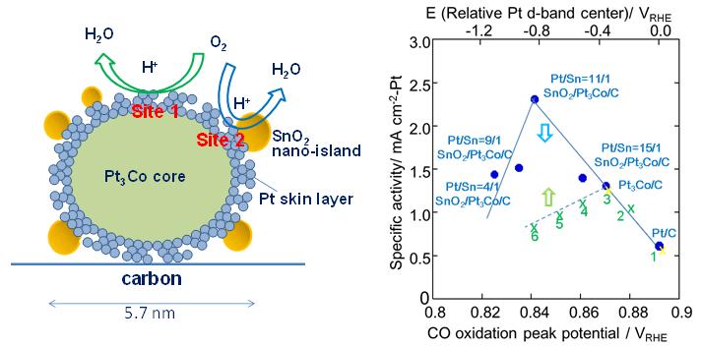
Caption
Left: Model structure and proposed oxygen reduction reaction activity sites (sites 1 and 2) for the nano-SnO₂-decorated Pt₃Co/C with Pt skeleton surface with compressive strain and defects/dislocations. Right: Correlation between the specific activity (SA) and the CO-stripping peak potentials for the SnO₂/Pt₃Co/C with different platinum/tin ratios: Pt/Sn = 4/1, 9/1, 11/1, and 15/1), Pt3Co/C, and Pt/C. The green dotted line represents averages from data for catalysts reported in other work - (1) Pt/C, (2) Pt₃Ni/C, (3) Pt₃Co/C, (4) Pt₃Fe/C, (5) Pt₃V/C, and (6) Pt₃Ti/C. These are also shown by scaling of the relative d-band center, where the values of Pt/C and Pt₃Co/C (yellow ×’s over blue dots) from reports of data for the other catalysts were normalized to the values in the present study.

Further information:
International Public Relations
The University of Electro-Communications, Tokyo
1-5-1 Chofugaoka, Chofu, Tokyo 182-8585
E-mail: ru-info-ml@uec.ac.jp
Website: http://www.uec.ac.jp/
About The University of Electro-Communications
The University of Electro-Communications (UEC) in Tokyo is a small, luminous university at the forefront of applied sciences, engineering, and technology research. Its roots go back to the Technical Institute for Wireless Commutations, which was established in 1918 by the Wireless Association to train so-called wireless engineers in maritime communications in response to the Titanic disaster in 1912. In 1949, the UEC was established as a national university by the Japanese Ministry of Education, and moved in 1957 from Meguro to its current Chofu campus Tokyo.
With approximately 4,000 students and 350 faculty, UEC is regarded as a small university, but with particular expertise in wireless communications, laser science, robotics, informatics, and material science, to name just a few areas of research.
The UEC was selected for the Ministry of Education, Culture, Sports, Science and Technology (MEXT) Program for Promoting the Enhancement of Research Universities as a result of its strengths in three main areas: optics and photonics research, where we are number one for the number of joint publications with foreign researchers; wireless communications, which reflects our roots; and materials-based research, particularly on fuel cells.
Website: http://www.uec.ac.jp/

If you would rather not receive future communications from International Public Relations, University of Electro-Communications, let us know by clicking here.
International Public Relations, University of Electro-Communications, 1-5-1 Chofugaoka Chofu, Tokyo, NA 182-8585 Japan

